|  |  |
| --- | --- |
| NAME | Muhammad Arslan Raza |
| ROLL# | 2020-EE-403 |

**Lab 2: Getting Started with Complier**

**Objective**: How to Start with Compiler and make 1st Program

**Task 1**: Printing Name on Output Screen

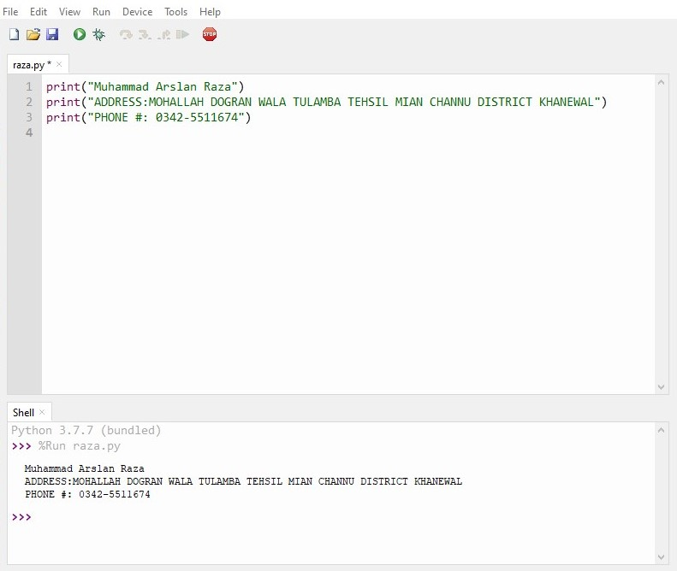

**Conclusion:** Today I learn How to start Compiler and Printing Name on Output Screen